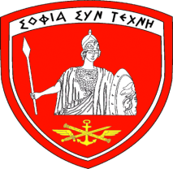
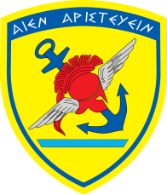

Hellenic National Defence General Staff |  | Hellenic National  Defence College

PERSONAL ADMINISTRATION FORM (PAF)

Name:
Surname:
Rank:
Nationality:
National ID Number:
Passport No:
Branch (Service):
Specialty:
Gender:
Status (Active/ Retired):
Date of Birth:
Place of Birth:
Single / married (Yes or No)
If married / Children (gender-age)
Does your family accompany you in Greece? (Yes or No)
Do you wish to be accommodated at the “Agios Andreas” Military Resort? (Yes or No)
Contact Information (in your Country)
Home UNIT/HQ:
Position Title:
Phone (personal mobile):
Phone (emergency or business):
E-mail:
Travel Schedule
Arrivals
Transportation means:
Arrival location in Athens:
Arrivals: (DD/MM/YYYY)
Arrival time:
Arrival Flight No (if applicable):
Departures (in the end of the course)
Transportation means:
Departure location from Athens:
Departures: (DD/MM/YYYY)
Departure time:
Departure Flight No (if applicable):
Additional Comments: (please provide any additional comments or remarks)

REMARKS

Please complete the Personal Administration Form and send it by email to POC not later than 1st July 2023. After 22 of July 2023, please, inform us for details that were not available at the time of submitting your PAF (e.g., travel arrangements etc.). POC will acknowledge receipt within 3 - 5 days.

POC: Colonel Nikolaos Anthis, ISC Coordinator, Hellenic National Defence College, Evelpidon 6 & Moustoxidi, GR: 11362, Athens, Greece Tel.: +30 210 889 6530/ 6500, e-mail: International@hndc.mil.gr

